**Project Name: Transport Buddy**

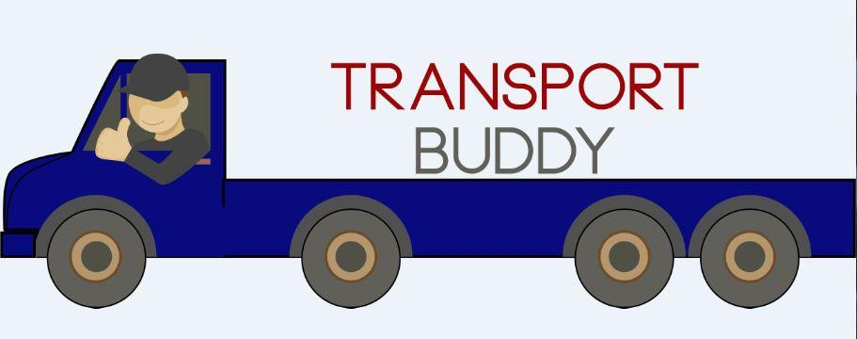

**Project Member:**

**Ashish Arya 220343120016**

**Chavan Manoj Balu 220343120028**

**Mokariya Hiren Vaju 220343120059**

**More Bhushan Vijay 220343120061**

**Abstract:**

The web application is made for the transport companies who use to spend additional fuel and labour charges when the vehicle is returning back to the location after completing a primary trip/scheduled delivery.

**Objective and Scope of Project**

In most of the scenarios, we have seen that the transport company owners have to cut down their profit when they do not get any booking when the vehicle is returning back to the location after completing the primary booking.

The objective of this application is to maximize the profit of the transport company owners by utilizing the return trip of their empty vehicle.

The moment a vehicle is allocated a primary booking, we will notify on our website about the return journey of the vehicle along with it’s exact locations. So that the users can book the vehicle on a discounted price, whenever the vehicle is on it’s return trip.

**Implementation Technologies:**

1. **Spring Framework:**

Spring Framework is a Java platform that provides comprehensive infrastructure support for developing Java applications. Spring handles the infrastructure so you can focus on your application.

Spring enables you to build applications from “plain old Java objects” (POJOs) and to apply enterprise services non-invasively to POJOs. This capability applies to the Java SE programming model and to full and partial Java EE.

**1.1 Features of Spring Framework:**

**1. Lightweight**

Spring is modular lightweight framework which allows you to selectively use any of its modules on the top of Spring Core.

**2. Inversion of Control (IOC)**

This is another top feature of Spring framework where application dependencies are satisfied by the framework itself. Framework creates the object in runtime and satisfies application dependencies.

**3. Aspect Oriented Programming (AOP)**

Aspect Oriented Programming (AOP) is very popular in programming world and in Spring it is well implemented. Developer can use Aspect Oriented Programming (AOP feature of Spring to develop application in which business logic is separated from system services.

**4. Container**

Spring provides their own container for managing the bean lifecycle.

**5. MVC Framework**

Spring MVC Framework is used for developing MVC based web applications.

**6. Transaction Management**

Spring framework provides generic Transaction Management layer which can be used with or without J2EE(JEE) environment.

**7. JDBC Exception Handling**

Spring provides their own abstraction of JDBC exception which further simplifies the exception handling in program.

**1.2 Advantages of Spring Framework:**

**1. Solving difficulties of Enterprise application development**

Spring is solving the difficulties of development of complex applications, it provides Spring Core, Spring IoC and Spring AOP for integrating various components of business applications.

**2. Support Enterprise application development through POJOs**

Spring supports development of Enterprise application development using the POJO classes which removes the need of importing heavy Enterprise container during development. This makes application testing much easier.

**3. Easy integration other frameworks**

Spring designed to be used with all other frameworks of Java, you can use ORM, Struts, Hibernate and other frameworks of Java together. Spring framework do not impose any restriction on the frameworks to be used together.

**4. Application Testing**

Spring Container can be used to develop and run test cases outside enterprise container which makes testing much easier.

**5. Modularity**

Spring framework is modular framework and it comes with many modules such as Spring MVC, Spring ORM, Spring JDBC, Spring Transactions etc. which can used as per application requirement in modular fashion.

**6. Spring Transaction Management**

Spring Transaction Management interface is very flexible it can configure to use local transactions in small application which can be scaled to JTA for global transactions.

1. **The JDBC Template**

The central class of the Spring JDBC abstraction framework is the **JdbcTemplate** class that includes the most common logic in using the JDBC API to access data, such as handling the creation of connection, statement creation, statement execution, and release of resource. The**Jdbc-Template**class can be found in the **org.springframework.jdbc.core**package.

The **JdbcTemplate** class instances are thread-safe once configured. A single **JdbcTemplate** can be configured and injected into multiple DAOs.

We can use the **JdbcTemplate** to execute the different types of SQL statements. **Data Manipulation Language** (**DML**) is used for inserting, retrieving, updating, and deleting the data in the database such as **SELECT**, **INSERT**, or **UPDATE** statements

**2.1** **MySQL**

MySQL, the most popular Open Source SQL database management system, is developed, distributed, and supported by Oracle Corporation.

**Features of MySQL:**

* **MySQL is a database management system.**

A database is a structured collection of data. It may be anything from a simple shopping list to a picture gallery or the vast amounts of information in a corporate network. To add, access, and process data stored in a computer database, you need a database management system such as MySQL Server. Since computers are very good at handling large amounts of data, database management systems play a central role in computing, as standalone utilities, or as parts of other applications.

* **MySQL databases are relational.**

A relational database stores data in separate tables rather than putting all the data in one big storeroom. The database structures are organized into physical files optimized for speed. The logical model, with objects such as databases, tables, views, rows, and columns, offers a flexible programming environment.

* **MySQL software is Open Source.**

Open Source means that it is possible for anyone to use and modify the software. Anybody can download the MySQL software from the Internet and use it without paying anything.

* **The MySQL Database Server is very fast, reliable, scalable, and easy to use.**

MySQL Server was originally developed to handle large databases much faster than existing solutions and has been successfully used in highly demanding production environments for several years. Although under constant development, MySQL Server today offers a rich and useful set of functions. Its connectivity, speed, and security make MySQL Server highly suited for accessing databases on the Internet.

* **MySQL Server works in client/server or embedded systems.**

The MySQL Database Software is a client/server system that consists of a multithreaded SQL server that supports different back ends, several different client programs and libraries, administrative tools, and a wide range of application programming interfaces (APIs).

1. **Hardware and Software Requirements (Minimum):**

**Hardware:**

1. Intel i5 processor 10th generation or later / AMD Ryzen 11th generation or later

2. 4 GB ddr4 ram.

3. Windows 10 Home edition or later.

4. 500 GB HDD Space

5. Data Connection 200 kbps

**Software:**

1. Eclipse 4.7 Oxygen
2. MySQL 5.7 with Workbench 8.0
3. Google Chrome version 79.0
4. Apache Tomcat Server 8.5
5. Maven Dependencies
6. **ER Diagram:**

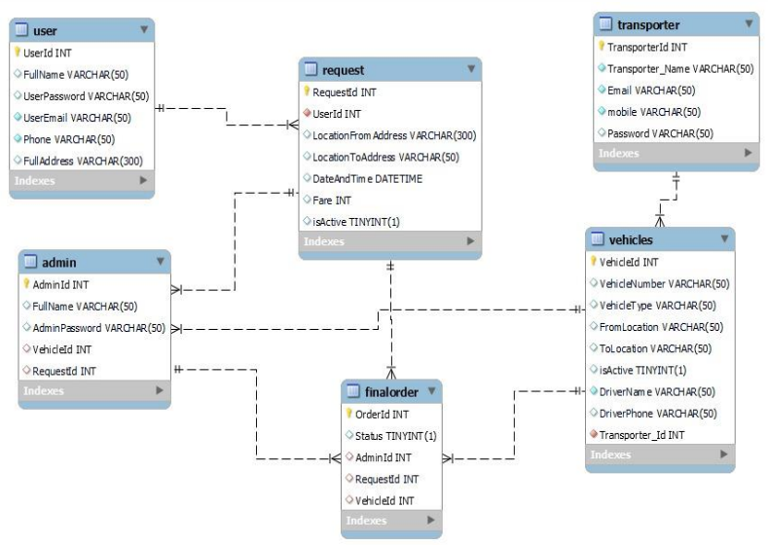

Figure 1: ER Diagram

**Data Flow Diagram**

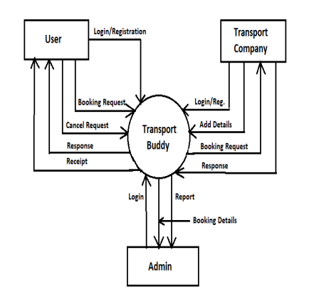

Figure 2: DFD Diagram

1. **Table Structures:**
2. **Table name:Users**

|  |  |  |  |  |
| --- | --- | --- | --- | --- |
| **Column name** | **Data Type** | **Allow Nulls** | **Constraints** |  |
| UserId | int | No | PRI | auto_increment |
| UserName | varchar(50) | YES |  |  |
| UserPassword | varchar(50) | YES |  |  |
| UserEmail | varchar(50) | YES | UNI |  |
| Phone | bigint | YES |  |  |
| FullAddress | varchar(300) | YES |  |  |

1. **Table name:Admin**

|  |  |  |  |  |
| --- | --- | --- | --- | --- |
| **Column name** | **Data Type** | **Allow Nulls** | **Constraints** |  |
| Admin_Id | int | No | PRI | auto_increment |
| Admin_Name | varchar(50) | YES |  |  |
| Admin_Password | varchar(50) | YES |  |  |

1. **Table name:Transporters**

|  |  |  |  |  |
| --- | --- | --- | --- | --- |
| **Column name** | **Data Type** | **Allow Nulls** | **Constraints** |  |
| TransporterId | int | No | PRI | auto_increment |
| Transporter_Name | varchar(50) | YES |  |  |
| Email | varchar(50) | YES | UNI |  |
| Phone | bigint | YES | UNI |  |
| TransporterPassword | varchar(50) | YES |  |  |
| UserName | varchar(50) | YES |  |  |
| Password | varchar(50) | YES |  |  |

1. **Table name:Vehicles**

|  |  |  |  |  |
| --- | --- | --- | --- | --- |
| **Column name** | **Data Type** | **Allow Nulls** | **Constraints** |  |
| VehicleId | int | NO | PRI | auto_increment |
| VehicleNumber | varchar(50) | YES | MUL |  |
| VehicleType | varchar(50) | YES |  |  |
| FromLocation | varchar(50) | YES |  |  |
| ToLocation | varchar(50) | YES |  |  |
| isActive | boolean | YES |  |  |
| Driver1Name | varchar(50) | YES |  |  |
| Driver2Name | varchar(50) | YES |  |  |
| Driver1Phone | bigint | YES | UNI |  |
| Driver2Phone | bigint | YES | UNI |  |
| TransporterId | int | YES | MUL |  |
| Fare | int | YES |  |  |

1. **Table name:Requests**

|  |  |  |  |  |
| --- | --- | --- | --- | --- |
| **Column name** | **Data Type** | **Allow Nulls** | **Constraints** |  |
| RequestId | int | NO | PRI | auto_increment |
| UserId | int | YES | MUL |  |
| LocationFromAddress | varchar(50) | YES |  |  |
| LocationToAddress | varchar(50) | YES |  |  |
| DateAndTime | Datetime | YES |  |  |
| Fare | int | YES |  |  |
| isActive | Boolean | YES |  |  |

1. **Table name:FinalOrder**

|  |  |  |  |  |
| --- | --- | --- | --- | --- |
| **Column name** | **Data Type** | **Allow Nulls** | **Constraints** |  |
| OrderId | int | NO | PRI | auto_increment |
| Status | Boolean | NO |  |  |
| AdminId | int | NO | UNI |  |
| TransporterId | int | NO | MUL |  |
| RequestId | int | NO | UNI |  |
| Userid | int | NO | MUL |  |

1. **Table name:OrderStatus**

|  |  |  |  |  |
| --- | --- | --- | --- | --- |
| **Column name** | **Data Type** | **Allow Nulls** | **Constraints** |  |
| Id | int | NO | PRI | auto_increment |
| OrderId | **int** | YES | **MUL** |  |
| PickedUp | varchar(50) | YES |  |  |
| OnTransit | varchar(50) | YES |  |  |
| Delivered | varchar(50) | YES |  |  |
| PickupDate | Datetime | YES |  |  |
| DeliveryDate | Datetime | YES |  |  |
| Status | Boolean | Yes |  |  |

1. **UML Diagrams:**

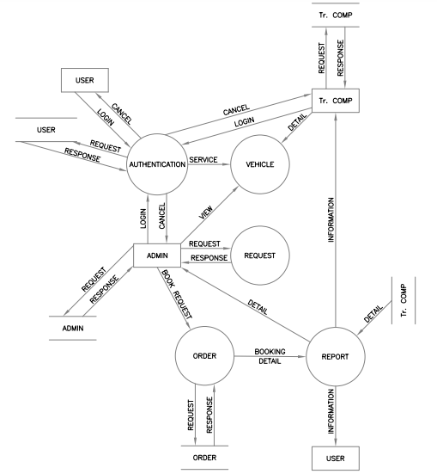

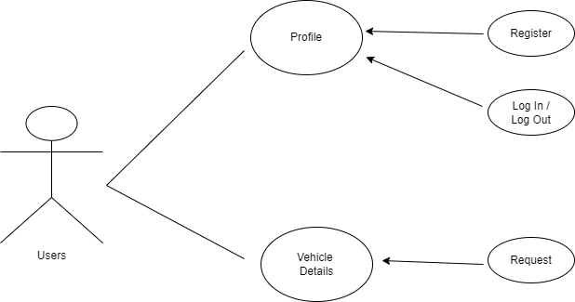

Figure 4: User Diagram

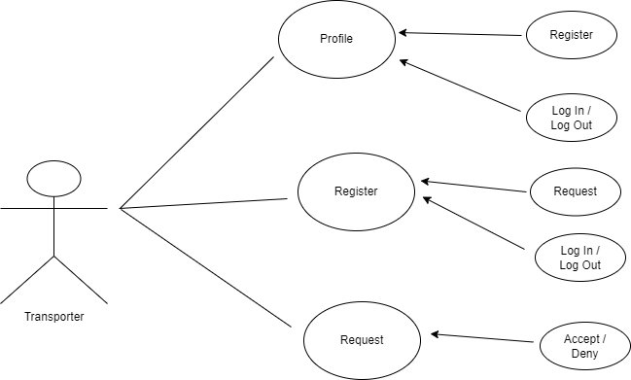

Figure 5 : Transporter Diagram

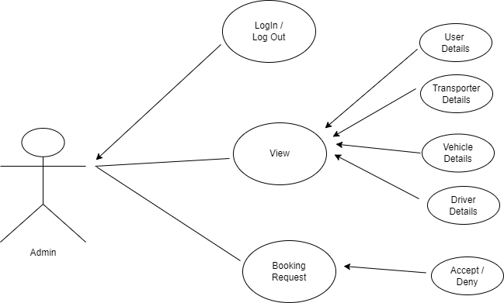

Figure 6: Admin Diagram

1. **End to End Flow of Application:**

**No. of User’s and Modules**

**• Users**

**1.** **Customers**: The customers will be given a login to the application to book a vehicle for booking. They have to specify the location and approximate load of the items. They will get a discount whenever they will get the opportunity to book a vehicle on it’s return journey. They will not be given the details of drivers until or unless they have confirmed their booking. Once the booking is confirmed, they will be provided the details of the journey and driver that will include name and phone number of the driver along with the vehicle model and number.

**2.** **Administrator**: He/she we will be given a special login so that he/she can check both the phases of the application and can connect between the customers and the drivers after checking all the necessary details such as load, pricing, pick and drop location, total duration and distance.

**3.** **Transport Companies**: They can register their vehicle and have to inform us about the details of the vehicle 24 hours prior to the completion of the primary journey of the vehicle. One transport company can register multiple vehicles. We will inform the customer about the pick up by adding 8 hours of the buffer so that the driver can take rest in the mean time and the vehicle will also get a time to cool down.

• **Modules**

**1. Customer management**: This module will be related to all the functional and non-functional aspects related to a customer who want to book a vehicle. Their registration, login, bookings (upcoming and cancelled), location, price.

**2. Driver management**: This module will be related to the functionality related to drivers. The drivers will be able to get the details of the available customers along with the location details in a particular radius.

**3. Transporter management**: This module will handle all the details of the vehicle that transporter/s will register with our application. We will maintain a record of the vehicle details associated with the respective driver.

1. **Future Scope Of Project**

* We can add a module of round trip(primary)
* We can implement live tracking feature
* Verification of users.
* Improvement in design.
* Mobile Application
* UPI payment
* Chat BOT

1. **Conclusion**

The Transport buddy web system will be designed and developed to overcome the drawbacks of old manual system and meet the requirement of modern age. This system will digitalize the Transportation industry and give more profit to Transporters. It will bring transparency between Admin, transporters and users by removing intermediates. It will save time & energy of everyone using this portal. Lastly it can be improved in future according to rising demand of users.

1. **References**

* Mr. Saleel Bagde for Database.
* Mrs. Harshita Maheshwari for HTML CSS & React also she was our project guide.
* Mrs. Mayuri Fakirpure for JAVA.
* https://www.stackoverflow.com
* https://www.React.com
* A special thanks to Infoway Management who arranged extra lab time for us.

**Thank You!**